IASSH Conference at NIRDPR, Hyderabad
Accommodation for Conference Participants:
For all registered participants attending the conference (who have submitted the filled-in registration form along with required registration fees on or before 10th Nov. 2017), the sharing accommodation is arranged at Himachal Guest House on the campus of National Institute of Rural Development and Panchayati Raj (NIRDPR- Govt. of India), Rajendra Nagar, Hyderabad. Once you reach NIRDPR campus, please report to Himachal Guest House. For those who have not registered, we are not in a position to arrange accommodation.
Guesthouse Reception Number : 040-24008500

Transportation: Pick up from Hyderabad and Secunderabad Railway Stations
NIRDPR has made arrangements for pick up of conference participants at specific timings (as given below) from two main Railway Stations - Hyderabad and Secunderabad. 35 Seater NIRDPR bus will be available to take the participants from Railway station to the NIRD Guest House where the accommodation is arranged for all participants.
On 15 th Nov. 2017
1. From Hyderabad (Nampally) Railway Station: Bus will be waiting here from 12 noon to 2.30 pm and leave for Guest House at 2.30 pm
Volunteers: Ms. Roshini & Ms. Vinaya, Mobile nos: 7995547528, 9908214845
2. From Hyderabad (Nampally) Railway Station: Bus will be waiting here from 5.30 pm to 7.30 pm. and leave for Guest house at 7.30 pm
Volunteer: Mr. Vamsi, Mobile no: 918276701
3. From Secunderabad Railway Station: Another bus will be waiting here from 5.30 pm to 7.30 pm. and leave for Guest house at 7.30 pm
Volunteer: Mr. Srikanth, Mobile no: 7981570704
On 16 th Nov. 2017
4. From Hyderabad (Nampally) Railway Station: Bus will be waiting here from 6 am to 8 am and leave for Guest House at 8 am
Volunteers: Mr. Srikanth, Mobile no: 7981570704, Mr. Vamsi, Mobile no: 918276701
Those participants reaching Hyderabad and Secunderabad railway stations during the timings mentioned above can avail the bus facility to reach NIRDPR campus. After reaching at the railway station (during the timings mentioned above)they can contact the volunteers (mentioned above) to find out the location of the bus. The vehicle in-charge at NIRDPR is Mr. Samuel, Mobile No - 9848781142.

All others arriving at Railway Stations, Bus Stations and Airport may make use of Taxi (ola, uber, meru and other taxi services, autos, etc) to reach the NIRDPR campus.

How to reach NIRDPR

Airport to NIRDPR

NIRDPR is about 22kms from airport. Participants coming from Shamshabad Airport to NIRDPR can avail pre-paid taxis, besides cabs like Meru, Skycab, Ola and Uber which would cost approximate within Rs. 500.

Railway Stations to NIRDPR
Those coming by train please note that the Secunderabad railway station is 25kms, Hyderabad Railway Station (Nampally) is within 15kms and Kachiguda Railway Station is 18kms from NIRDPR. Pre-paid taxis are available besides cabs like Meru, Ola and Uber which would cost approximate within Rs. 300 - 400 from Kachiguda & Nampally Railway Station to NIRDPR.

Main Bus stations: 1. Mahatma Gandhi Bus Stand (MGBS) 2. Jubilee Bus Stand (JBS)
Distance from Mahatma Gandhi Bus Stand is around 15kms. Distance from Jubilee Bus Stand to NIRDPR is around 20kms. Cabs and autos are available and it may cost around Rs. 300 – 400.

Please refer to the route maps below in case of any difficulties.

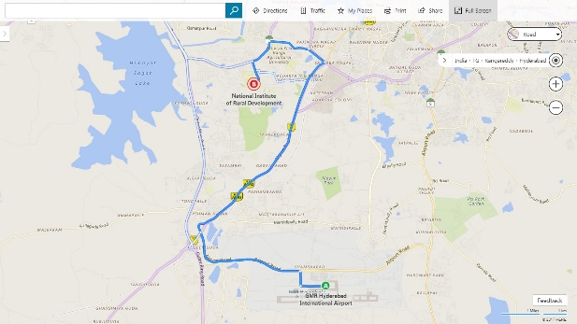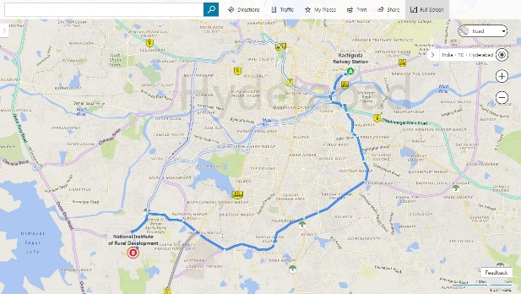
Airport to NIRDPR Kachiguda to NIRDPR
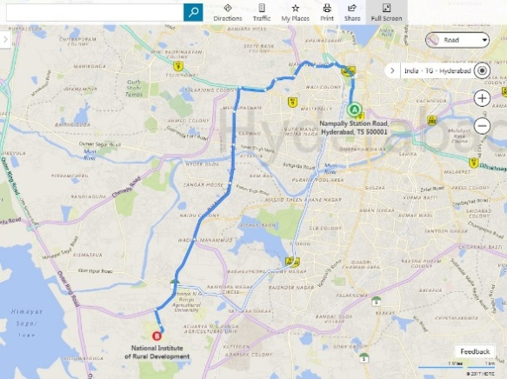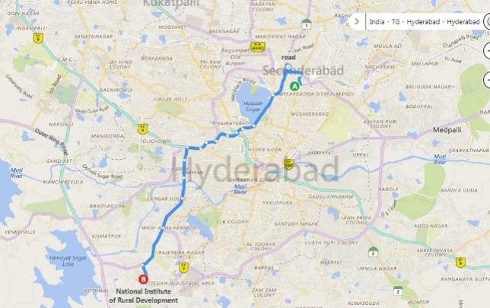
Hyderabad (Nampally) to NIRDPR Secunderabad to NIRDPR
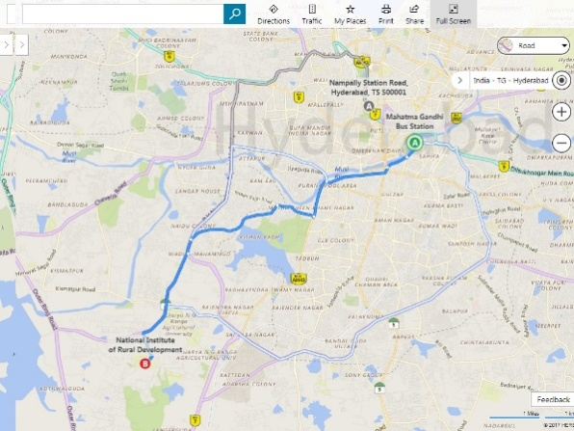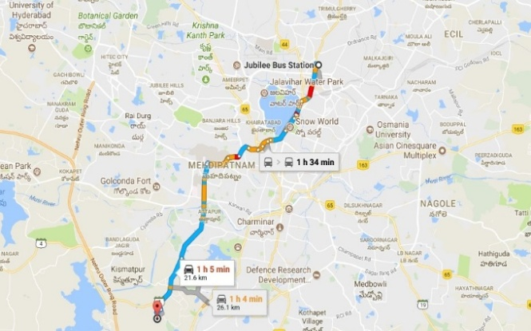
Mahatma Gandhi Bus Stand to NIRDPR Jubilee Bus Stand to NIRDPR

